Day 13 — Spark SQL Basics

Creating customer.csv to save the data
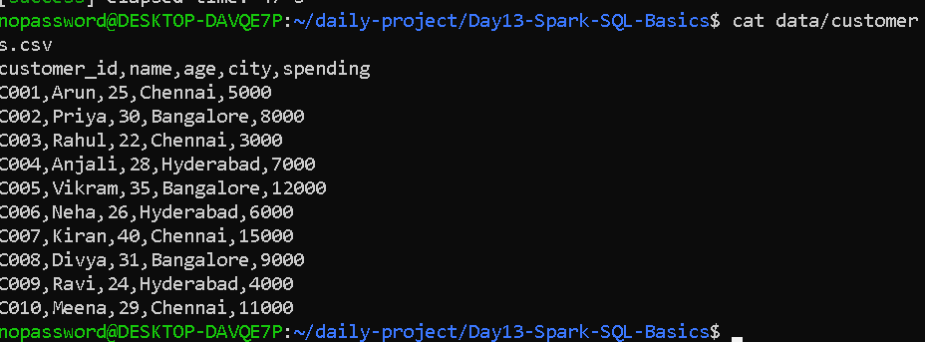

Creating build.sbt
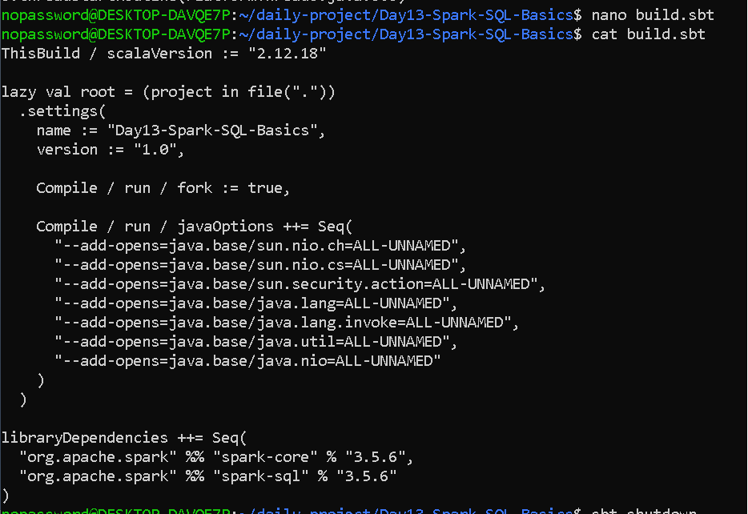

Basic sql commands
import org.apache.spark.sql.SparkSession
import org.apache.spark.sql.functions._

object SparkSQLBasics {

def main(args: Array[String]): Unit = {

val spark = SparkSession.builder()
.appName("Day13-Spark-SQL-Basics")
.master("local[*]")
.getOrCreate()

spark.sparkContext.setLogLevel("WARN")

// Step 1: Read CSV file
val customers = spark.read
.option("header", "true")
.option("inferSchema", "true")
.csv("data/customers.csv")

println("===== CUSTOMER DATA =====")
customers.show()

// Step 2: Inspect schema
println("===== SCHEMA =====")
customers.printSchema()

// Step 3: Select columns
println("===== SELECT CUSTOMER NAME AND CITY =====")
customers
.select("name", "city")
.show()

// Step 4: Filter customers
println("===== CUSTOMERS WITH SPENDING > 7000 =====")
customers
.filter(col("spending") > 7000)
.show()

// Step 5: Create a new column
val customerAnalytics = customers.withColumn(
"customer_category",
when(col("spending") >= 10000, "Premium")
.when(col("spending") >= 5000, "Regular")
.otherwise("Basic")
)

println("===== CUSTOMER CATEGORY =====")
customerAnalytics.show()

// Step 6: Register temporary view
customerAnalytics.createOrReplaceTempView("customers")

// Step 7: Run SQL query
println("===== PREMIUM CUSTOMERS =====")

val premiumCustomers = spark.sql(
"""
SELECT customer_id, name, city, spending, customer_category
FROM customers
WHERE customer_category = 'Premium'
"""
)

premiumCustomers.show()

// Step 8: City-wise analytics
println("===== CITY-WISE CUSTOMER ANALYTICS =====")

val cityAnalytics = spark.sql(
"""
SELECT
city,
COUNT(*) AS customer_count,
ROUND(AVG(spending), 2) AS average_spending,
SUM(spending) AS total_spending
FROM customers
GROUP BY city
ORDER BY total_spending DESC
"""
)

cityAnalytics.show()

// Step 9: Stop Spark
spark.stop()
}
}

OUTPUT—

